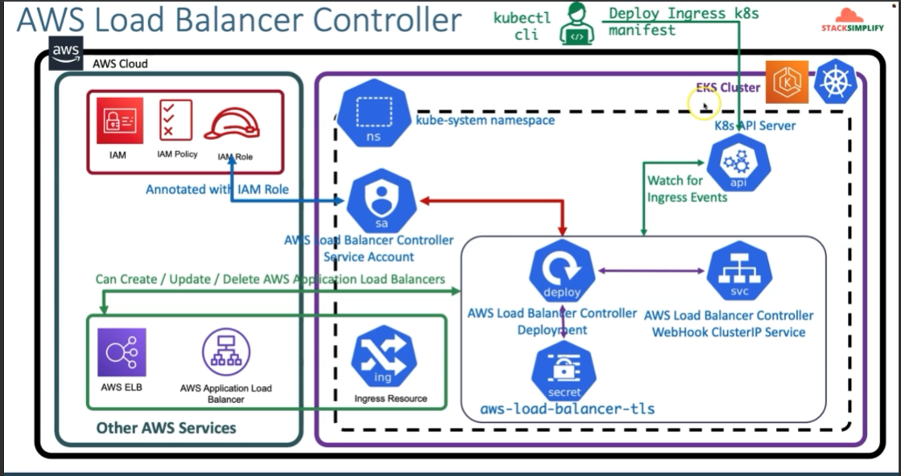

We create an IAM policy / role that has all the permissions to create an ALB. We associate this role with a service account that is created in the EKS cluster. We then install a Load Balancer Controller in the EKS cluster using the above service account. So now the Load Balancer Controller in the EKS cluster has the required permissions to create a ALB in AWS.

The Load Balancer Controller keeps polling the Kubernetes API server for Ingress events. When we submit a request for creation of an Ingress resource using kube manifests / kubectl, the load balancer controller goes ahead and creates the Ingress Service / ALB and related resources.